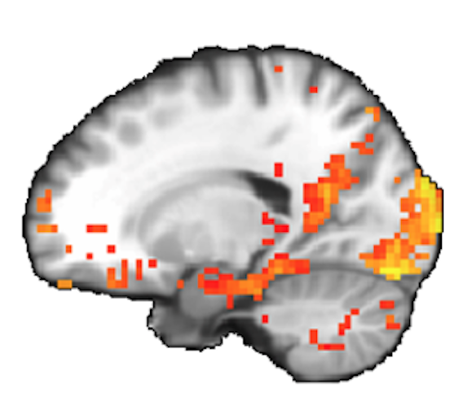
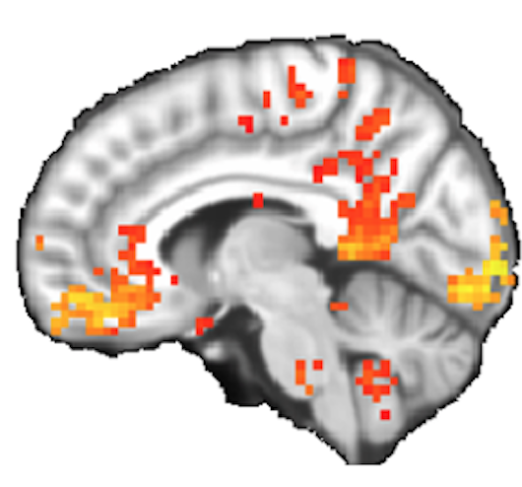
OLDER VOLUNTEERS NEEDED
If you are:
- 65+ years old
- Neurologically normal
- Fluent in English
- Want to earn $10/hour

JOIN THE COMPLEX MEMORY STUDY!
We are seeking volunteers who are at least 65 years old to participate in studies investigating the way we learn and remember information and how this is affected by aging. Each session takes between 1-2 hours and pay $10/hour. These studies are conducted by Dr. Zachariah Reagh in the Department of Psychological & Brain Sciences at Washington University.

Contact us!
Telephone: 314-935-0212
Email: complexmemlab@wustl.edu

Complex Memory Study  314-935-0212  complexmemlab@wustl.edu | Complex Memory Study  314-935-0212  complexmemlab@wustl.edu | Complex Memory Study  314-935-0212  complexmemlab@wustl.edu | Complex Memory Study  314-935-0212  complexmemlab@wustl.edu | Complex Memory Study  314-935-0212  complexmemlab@wustl.edu | Complex Memory Study  314-935-0212  complexmemlab@wustl.edu | Complex Memory Study  314-935-0212  complexmemlab@wustl.edu | Complex Memory Study  314-935-0212  complexmemlab@wustl.edu | Complex Memory Study  314-935-0212  complexmemlab@wustl.edu | Complex Memory Study  314-935-0212  complexmemlab@wustl.edu | Complex Memory Study  314-935-0212  complexmemlab@wustl.edu

